Project Development Phase
Model Performance Test

Date | 08 October 2026
Team ID | 9100MindMesh
Project Name | Streamlite Procurement
Maximum Marks | 10 Marks

Model Performance Testing:
Project team shall fill the following information in model performance testing template.
S.No. | Parameter | Values | Screenshot
 | Metrics | Regression / Classification Model:  Not applicable – Streamlite is a rule-based ServiceNow Flow Designer automation; no machine learning model is used.  Functional test result:  Standard Laptop request REQ0010001 placed → approval requested and approved → flow triggered → catalog task SCTASK0010001 created automatically (Assignment group: Hardware; Short description: Laptop needs to be configured). Result: Passed. | 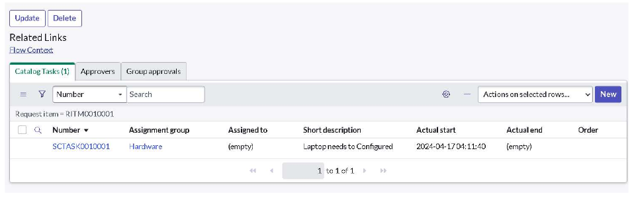
 | Tune the Model | Hyperparameter Tuning - Not applicable (no ML model).  Validation Method - End-to-end test order through the Service Catalog (REQ → RITM → SCTASK). Flow configured with Application: Global, Run As: System User, Approval: Approved, then assigned under Process Engine of the Standard Laptop catalog item and activated. | 